Product Name | 7152 Chicken Breast Escalope 140g-160g
Specification Reference Number | FPSPEC-027
Version Number | 7
Product Claims/Assured Status | Red Tractor Assured
Product Code (If applicable) | 7152
Country of Origin | UK
COMPANY/MANUFACTURERS DETAILS
Company/Manufacturers Name
Company/Manufacturers Address
Telephone Number | 01323 873645
Fax Number
Technical Contact
Telephone Number
Email Address
Sales Contact
Telephone Number
Email Address
Emergency out of hours contact

Product Description | Vacuum Packed Chicken Breast Escalope sourced from Red Tractor Assured Farms, cut, shaped and weighed to customer requirements.
Process Description | Live birds received from local Red Tractor Assured farms, slaughtered, eviscerated and air chilled. Weight graded to size, machine cut into portions, Breast fillet removed from carcass, cut/shaped, piece weighed (to customer requirements), piece counted or weighed into vacuum bags (to customer requirements), labelled, packed into cardboard boxes, box strapped, box weighed, metal detected, and stored in cold storage prior to despatch
Ingredients | 100% Chicken
Cutting/Process Specification | 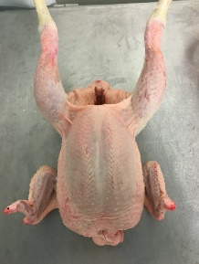  Whole Bird  Automatic Machine Cut into portions  Breast fillet removed from carcass  Woody, bruised or damaged fillets are rejected  Trimmed as necessary  Cut/Shaped into required size  Pieces weighed to customer requirements  Pieces counted or weighed into vacuum bags and Vacuum sealed & packed (CCP4)  Packs labelled  Boxed into cardboard boxes  Strapped/box weighed/box labelled  Metal Detected (CCP)  Cold Storage prior to despatch
Primary Packaging Specification | 300 x 350mm or 350 x 450mm 9-layer coextruded multilayer barrier film
Secondary Packaging Specification | 500 x 299 x 100mm - base  508 x 307 x 100 mm – lid cardboard box
Tertiary Packaging Specification | Wooden pallet, clear stretch film
Total Shelf Life | If fresh: Pack + 13 days (all subject to validation)  If Frozen shelf life: Pack/Freeze Date + 12 Months
Storage Conditions | Keep refrigerated. 0°c - 3°C (Chilled, Vacuum Packed)  Keep frozen -18°C (if Frozen), defrost thoroughly prior to use and once defrosted use within 24 hours
Special Conditions | This is a raw product, cook thoroughly prior to consumption
Weight/Pack Contents | Chicken breast escalope weights are available in different weight bandings, all have different product codes please specify with sales dept:  Piece weight 140g-160g: 20 pieces per bag x 2 bags per box (ave.6kg per box)
Labelling/Coding | Supplier  Product Description  Net Weight  Use by = DDMMYY  Traceable barcode: Unique to case

Allergen Status | Product contains no allergens. Allergens are not permitted in production & storage areas
Microbiological Standards – Expected Range
TVC | <1000000 cfu/g
Coliforms | <50000 cfu/g
Staphylococcus Aureus | <100 cfu/g
Salmonella | Not detected in 25g

Suitable For:
Vegetarians | No
Vegans | No
Halal | Yes
Kosher | No

Quality Attribute Parameters
Acceptable criteria | Target | Acceptable Levels | Unacceptable Levels
Appearance | Free from bruising  Free from excessive fat  Free from blood spotting and haemorrhage  Free from feathers  Free from foreign body contamination  Free from Bone  All Pieces weight within specified banding (i.e. 140g-160g) | Redness <10mm max 10%  Bruising <10mm max 10%  Blood Spotting <10%  Fat present on one surface max 2%  Max 2 Bone fragments <5mm in 10Kg | >10% redness <10mm on one surface  Redness covering >10mm  >10% Bruising <10mm  Bruising found >10mm  Blood Spotting >10%  Fat present on more than one surface max 2%  >2% of Fat present on one surface area  >2 Bone fragments <5mm in 10Kg  Bone found >5mm  Piece weights not in declared band weights (i.e. declared weight of 140g-160g it is not acceptable to have weights <110g or >130g)
Colour | pink colour of flesh | pink colour of flesh | Excessive redness, Green/Yellow Discolouration
Aroma | Clean, fresh, raw meat aroma | Clean, fresh, raw meat aroma | Sour, bitter, damp or off taints

Target and Acceptable Quality Attribute Photos
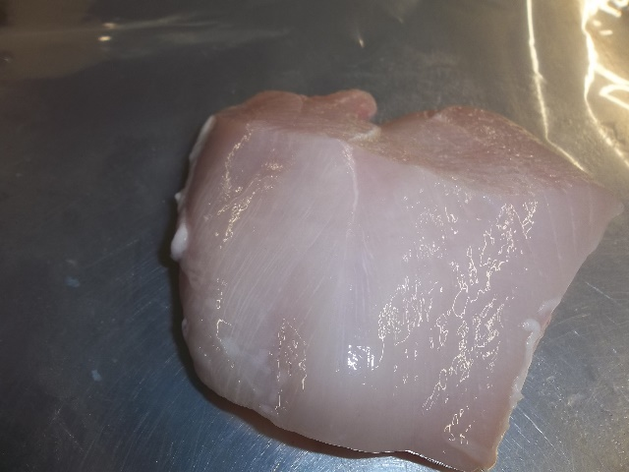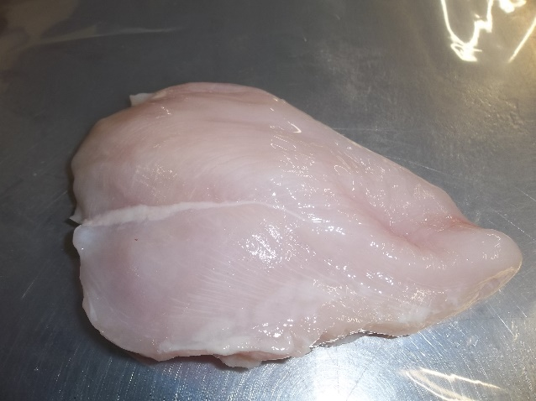
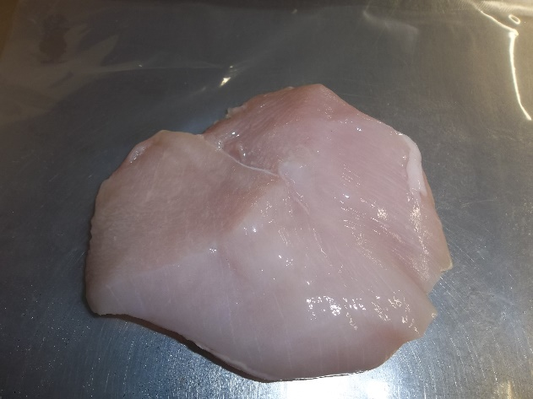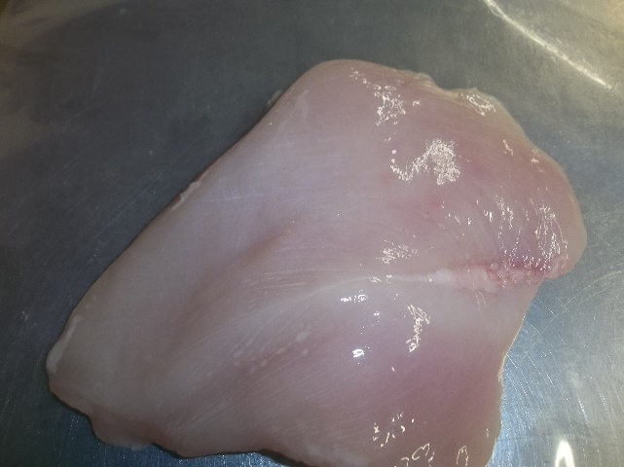
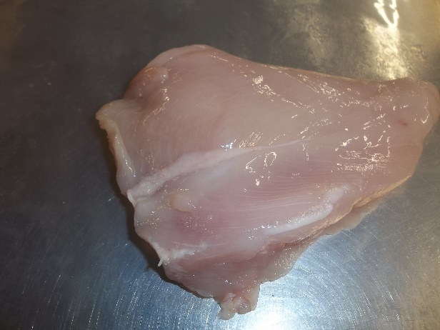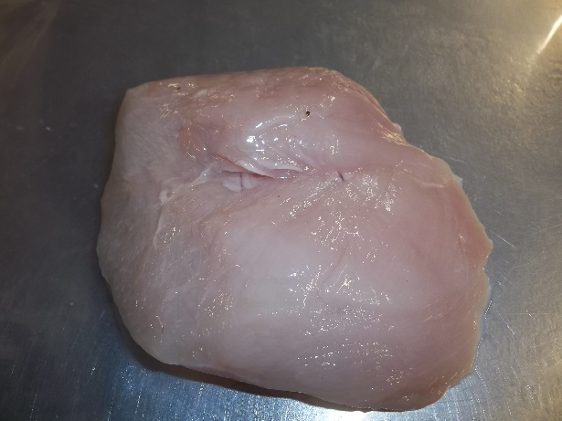
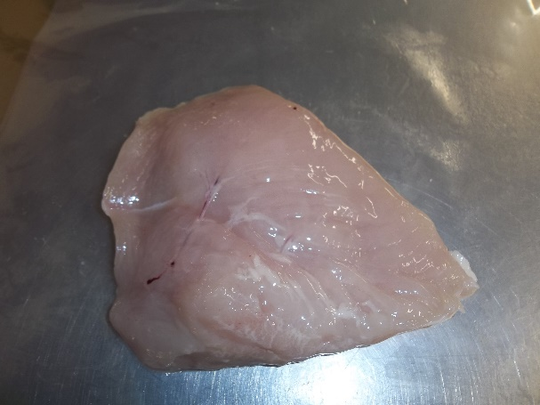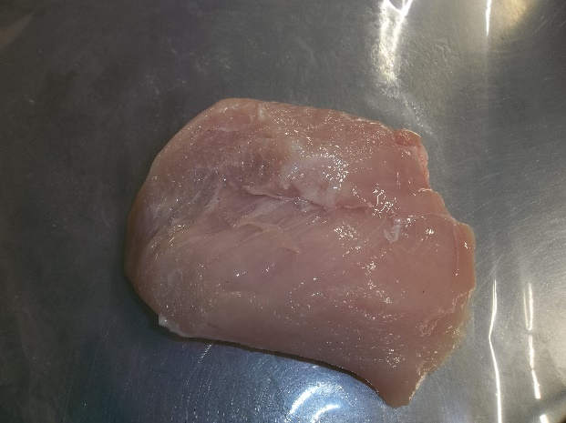
Tolerable Quality Attribute Photos
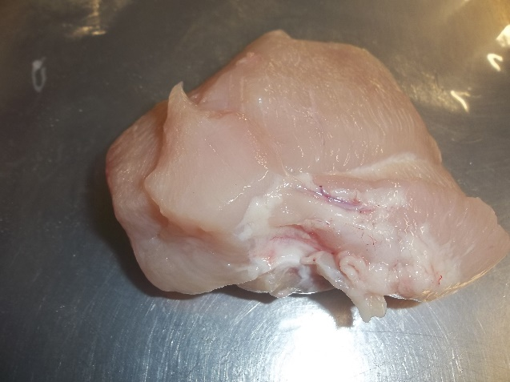
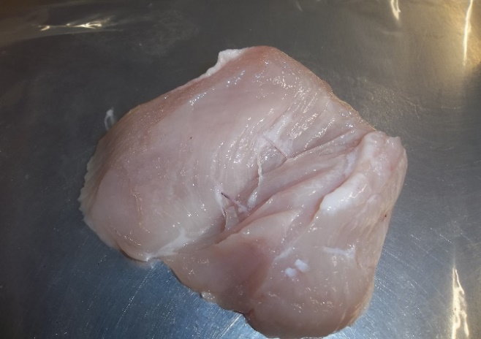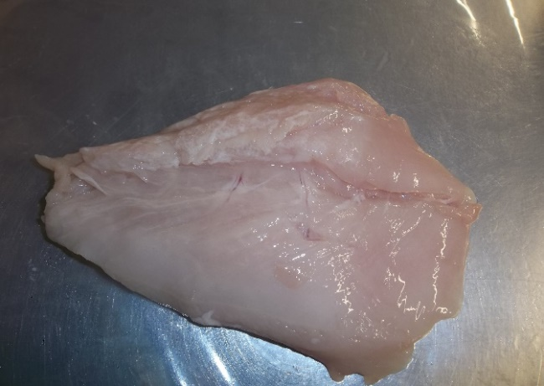
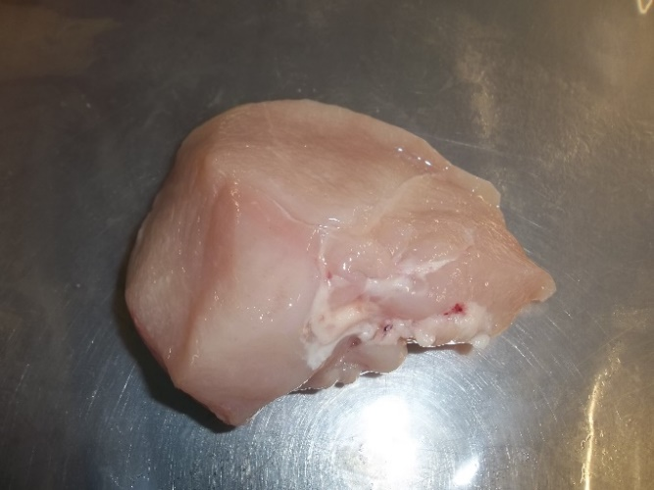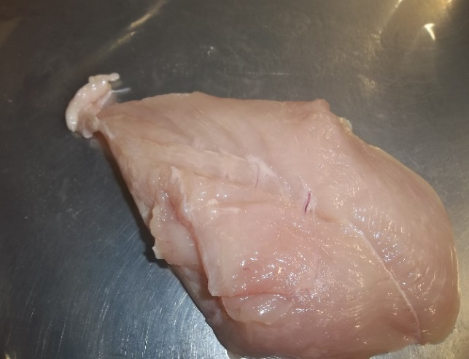

Unacceptable Quality Attribute Photos
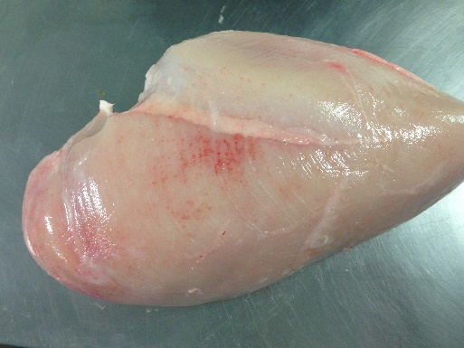
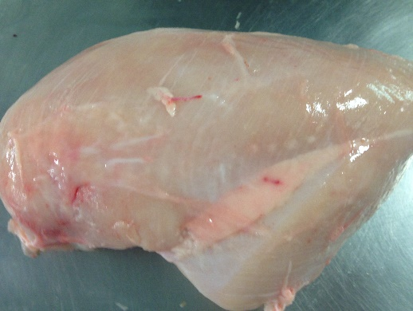
woody breast
woody breast
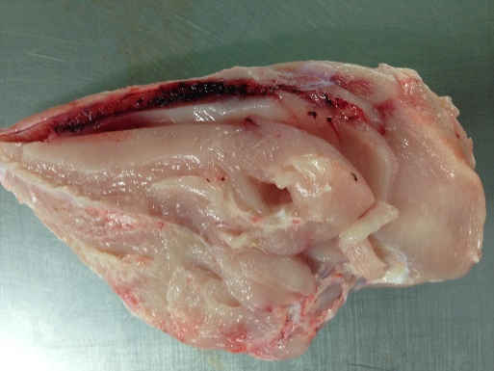
bruising
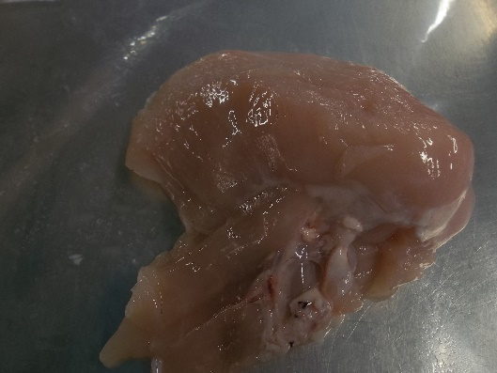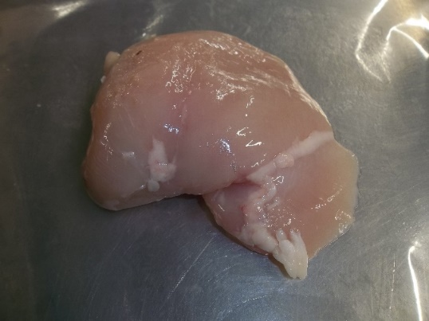
elongated shape elongated shape

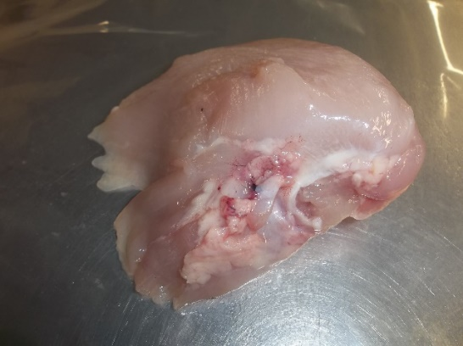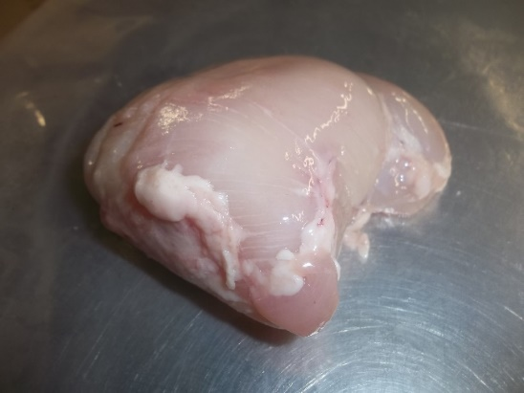
Excess fat poor trimming

