Product
Product name | OVINE LEG LAMB – SLASH BONED (frESH)
Legal Description: | OVINE LEG LAMB – SLASH BONED (frESH)
Product Description  (describing the product and the intended use and usage levels if applicable) | Prepared from a chump-on, shank off femur bone leg by the removal of the femur bone using the slash boning method.  Individually vac packed and boxed in cases of 8.
Delivery and storage conditions  (Ambient, Chilled …) | Fresh chilled < +5° C maximum +7°C  Frozen <-18C maximum -15ºC
Shelf Life | Fresh chilled = Pack +14days  Frozen = Pack + 24 months
Picture:
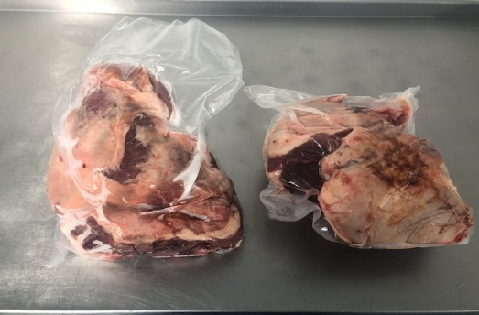
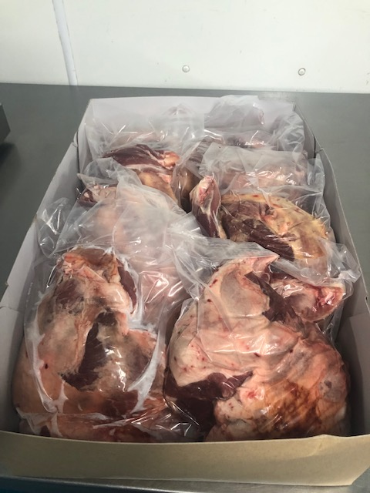

Contacts
DAY to DAY BUSINESS  Name:  Phone:  Email: | JOHN BURGESS  07778 305248  jburgess@easternmeatsupplies.co.uk
TECHNICAL MANAGER  Name:  Phone:  Email: | ROBERT BURGESS  01480 463330  rburgess@easternmeatsupplies.co.uk

Ingredients
Ingredient declaration (targets) | OVINE LEG LAMB – SLASH BONED
Processing Aids | N/A

Allergen Targets
PRESENCE OR ABSENCE OF ALLEGERNS:
Y means contains; N means free from; ? means may contain traces
Cow’s Milk Protein | N | Lactose | N | Chicken’s egg | N
Soya Protein | N | Soya Oil | N | Gluten | N
Wheat | N | Rye | N | Beef | Y
Pork | N | Chicken | N | Fish | N
Shellfish/crustaceans | N | Maize | N | Cocoa | N
Yeast | N | Legumes/pulses | N | Nuts | N
Nut Oil | N | Peanuts | N | Peanut Oil | N
Sesame | N | Sesame Oil | N | Glutamate | N
Sulphite (E220 – E227) | N | Benzoic Acid and parabens (E210 – E219) | N | Azo Dyes | N
Tartrazine (E102) | N | Cinnamon | N | Vanillin | N
Coriander | N | Celery | N | Umbelliferae | N

Ingredient contains targets
Y means contains/suitable; N means free from/unsuitable; ? means traces may be suitable
Milk Constitutes | N | Milk Powder | N | Soya Lecithin | N
Soya Flour | N | Wheat Flour | N | Wheat Starch | N
Egg Constitutes | N | Egg Powder | N | Egg Yolks | N
Nuts or Nut Derivatives | N | Seeds or Seed Derivatives | N | Animal Products | Y
Fish or Crustaceans | N | Artificial Sweeteners | N | Soya Meal | N
Vegetarians | N | Ovo – Lacto Vegetarians | N | Vegans | N
Coeliac | N | Diabetics | N | Kosher | N
Artificial Colours | N | Artificial Preservatives | N | Halal | N
Phosphates | N | Alcohol | N
Genetically Modified Organisms | N | Animal origin, were animals fed on feed/feed ingredients derived from Genetically Modified soya, maize or non-EU rapeseed? |  |  | N

Transport / Storage conditions
 | Target | Maximum
Storage | <4 degrees | 7 degrees
Transport | <4 degrees | 7 degrees
Product temperature should not exceed 7°C and air temperature should be returned to < 4° C within two hours (to allow for defrost cycle in fridges and delivery)

Microbiological standards
Property | m | M | UOM | Method
Salmonella | 0 | 0 | cfu/25g | ISO 6579
Staphylococcus aureus | 20 | 200 | cfu/g | ISO-6888
Escherichia coli | 10 | 100 | cfu/g | ISO 6391
Indicator/Utility Microorganisms
Property | m | M | UOM | Method
Aerobic Plate Count | 100000 | 1000000 | cfu/g | ISO-4833
Enterobacteriaceae | 1000 | 10000 | cfu/g | ISO-7402

All values are based on Public Health Laboratory standard

When values are given for n and c the standards are based on the ICMSF system with definitions of:

m: Level of the test organism which is acceptable and attainable in food. It separates good quality from marginally acceptable quality; up to and including M.

M: The upper acceptable concentration of a test organism. A count above M for any sample unit is unacceptable.

When no values are given for n and c the standards for m and M represent GMP and Maximum levels respectively: defined as:

GMP:
A level of microorganisms present in the end products which is acceptable for food products. If the number of microorganisms exceeds this (GMP) value, but is below the maximum limit, corrective actions should be taken within the manufacturing operation.

Maximum:
Levels of microorganisms above maximum indicate an end product of unacceptable microbiological quality. In this context, unacceptable means a significant deviation from accepted GMP standards and/or levels of organisms that could adversely affect end product safety/quality.

Physical analysis
Attribute | Target | Max | Freq
Bones | Nil | Nil | N/A
Gristle | N/A | N/A | N/A
Veins | N/A | N/A | N/A
Irradiation | Nil | N/A | N/A

Packaging requirements

- The raw material will be in food grade vacuum pouches inside euro boxes and palletised to a maximum height of 1.5m

- Packaging will not be assembled using metal rivets, metal staples, metal wire or metal thread.

- Palletised material will be stacked neatly with no overhang. Pallets will be stable and protected with an impermeable wrap covering the entire pallet load.

- The material will be transported in clean, hygienic, physically sound conditions.

- Upon receipt at the user's storage location all packaging will be unsoiled, intact and undamaged.

