Product Description
Product Title: | Pork Collars
Product Code:
Visual Lean Target: | 90%
Species: | PORK
Welfare Standard: | BQAP
Storage: | Frozen from -18˚C
Supplier:
Health Mark:

Ingredients
Pork

Processing Details
Shoulders are cut from carcase
Collar is removed from shoulder
Collar trimmed to specification
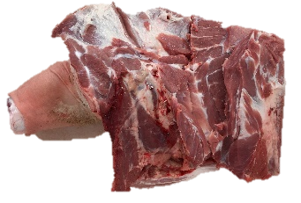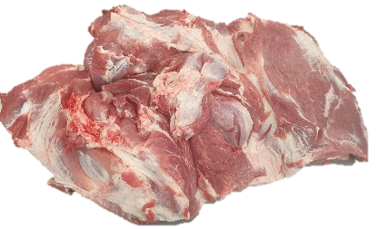

Acceptable Standards
Food contact packaging is blue
Fat is less than 10%
Free from chemical, physical and microbial contamination

Unacceptable Standards
Food contact packaging other than blue
Damaged box, torn liner
Fat greater than 10%
Presence of bone chips, hard gristle or bruising
Contamination of taints and odours, physical, chemical or microbiological

Packaging Format & Shelf Life
Food contact packaging: | Blue liner
Outer packaging: | Plain Euro Box
Pack Weight: | Catch Weight ~20kg
Kill to pack max: | Kill +3 days
Shelf life: | Kill + 1 year

Allergen Information
None Known
Labelling Details
All products will be labelled with the following as a minimum:
- Label Code
- Product Code
- Process by
- Product description
- Country of Origin
- Barcode
- Net weight
- Tare
- Production date
- Kill date
- Traceability reference
- Storage instructions
- Health Mark
- Address

Process Controls Foreign Body Detection Equipment
As a minimum the product will be metal checked by an inline metal detector conforming to BRC requirements.
All raw products (i.e. carcases, dolavs) are visual inspection only, not metal detected.
Foreign body detection equipment used: | Inline metal detection
Level of detection: | 7mm Ferrous
 | 7mm Non Ferrous
 | 7mm Stainless Steel
Other: | N/A

Process Controls:

Microbiological Standards | Target | Reject
TVC | <10*5 | >5x10*5
Coliforms | <5x10*2 | >5x10*3
E Coli | <20 | >100
S. Aureus | <5x10*2 | >5x10*3
E. Coli 0157 | N/A | N/A
Salmonella | Negative in 25g | Positive in 25g
Frequency of sampling: | Weekly

Nutritional Information
Energy | 188kcal
Total Fat | 12.2g
Saturated Fat | 4.53g
Protein | 18.7g
Sodium | 44.7mg

Warranty Statement
Raw materials and products supplied are compliant with Red Tractor requirements. Traces to farm can be conducted to validate this upon request. Material is fit for human consumption and compliant with all current relevant UK and EC legislation including but not limited to:
- EU Hygiene Regulation 852/2004, 853/2001, 627/2019
- The Food Safety Act 1990 and all relevant amendments made thereafter
- The Materials and Articles in Contact with Food Regulations 1987 and all relevant amendments made thereafter
We undertake to carry out in relation to the food product or packaging intended for food use supplied by us such checks as a diligent supplier would reasonably carry out in order to ensure compliance with Acts and regulations mentioned and we agree to supply you, on demand, with the results of such checks in so far as they are relevant to indicating the lawful nature of the foods supplied by us to you.

Specification Approval
Signed on behalf of supplier: | Signed on behalf of customer:
Name: Irina Sircu | Name:
Position: QS Technologist | Position:
Signature: I. Sircu | Signature:
Date: 24/02/2023 | Date:

